 |  | Substation |  |  | BERTAM VALLEY |  |  |  |  |  |  |  |  |  |  |  |  | Date: 02/06/2026
 |  | Equipment |  |  | TRANSFORMER |  | Manufacturer |  |  |  |  |  |  |  |  | EWT |  | Time: 9:20 AM
 |  | Model |  |  | HERMETICALLY SEAL |  | Rating |  |  |  |  |  |  |  |  | 750kVA |  | Humidity: 79%
 |  | Area |  |  | CABLE |  |  |  |  |  |  |  |  |  |  | Tx No. |  | 1
Location |  | LV SIDE
 | IR IMAGE |  |  |  |  |  |  |  |  |  |  | VISUAL IMAGE
 |  |  |  |  |  |  |  |  |  |  |  | 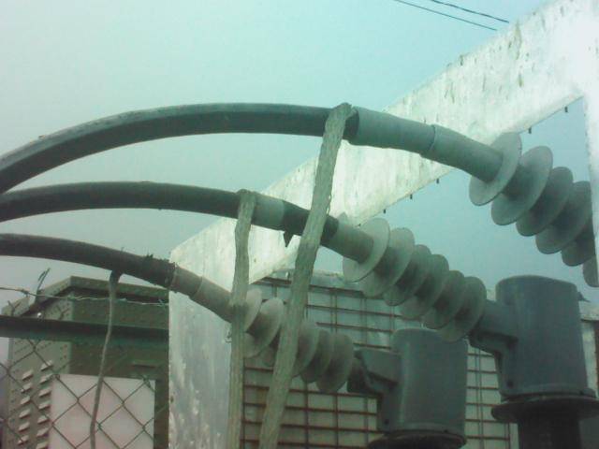
 | PARAMETER |  | VALUE
 | Spot Temp.1 (Sp1) |  | 21.5 °C |  |  |  |  |  |  |  |  |  |  |  | PARAMETER |  |  | VALUE
 | Spot Temp. 2 (Sp2) |  | 24.8 °C |  |  |  |  |  |  |  |  |  |  |  | Serial No. |  |  | EWT55674
 | Average Temp. (Ar1) |  | 23.3 °C |  |  |  |  |  |  |  |  |  |  |  | Heater (A) |  |  | -
 | Ambient Temp. |  | 21 °C |  |  |  |  |  |  |  |  |  |  |  | CB Position |  |  | -
 | Delta T ( ∆ T) |  | 3.3 °C |  |  |  |  |  |  |  |  |  |  |  | Busbar Position |  |  | -
 | Load (A) |  | - |  |  |  |  |  |  |  |  |  |  |  | Cable Type |  |  | XLPE
 | Defect
Analysis & Recommendations:

Analysis: No Anomaly.
Recommendation: -

